Full name: Patrícia Pelufo Silveira

Contact email: patricia.silveira@mcgill.ca

Brief Bio: Patrícia Pelufo Silveira, MD, Ph.D. (she/her), is a renowned DOHaD scientist whose research has transformed our understanding of early life effects, metabolism, and behavioral outcomes. As an Associate Professor at McGill University, Dr. Silveira has led pioneering studies on gene-environment interactions and food preferences, influencing both fundamental science and real-world applications. She has earned prestigious recognitions, including being an elected member of the College of New Scholars of the Royal Society of Canada and the National Scientific Council on the Developing Child. Her work has been featured in top-tier journals such as JAMA Pediatrics, Biological Psychiatry and Nature Mental Health. A passionate mentor and advocate for scientific innovation, Dr. Silveira continues to shape the future of DOHaD through cutting-edge research, interdisciplinary collaborations, and impactful public engagement.

Photo:
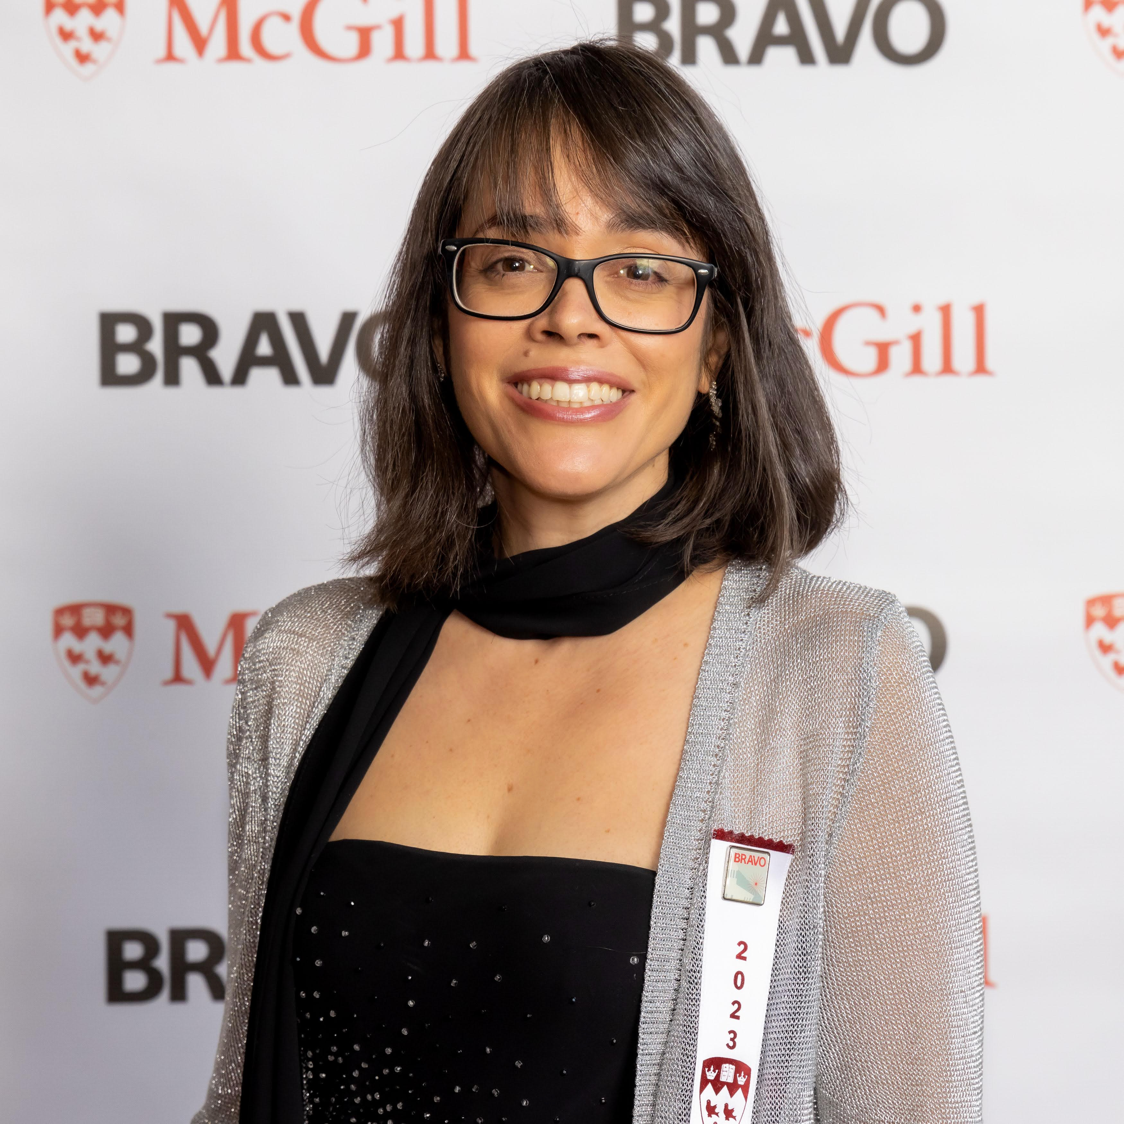

Title of the talk: Brain insulin as a modulator of early life effects on physical and mental health

